Pawnshops exhibition sets the image of society through pawnshops
Pawnshops and second-hand shops can be found in every city. In these shops we find not only things to use, but also memories and keepsakes. The exhibition Pawnshops: Places of the Marginal Economy by Prokop Matej at Gallery 45 000 l: Volume for Engaged Architecture brings the culture and significance of pawnshops to life. The exhibition opens on Tuesday, March 7 at 6pm. As part of Brno Art Week, a guided tour of Brno pawnshops will take place on Sunday 23 April 2023 at 15:00. The exhibition will be on display until 13 May.
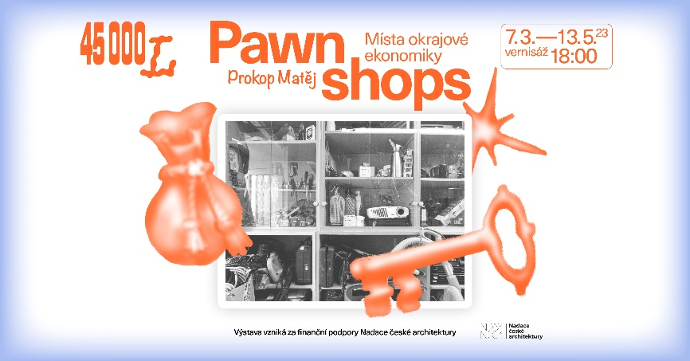
The first exhibition of this year in the 45 000 l Gallery: Volume for Engaged Architecture develops the studio work of Prokop Matej, developed at Delft University of Technology, and transfers the typology and format of the pawnshop/bazaar from their typical segregated locations to an arcade in the centre of Brno.
The exhibition depicts the typology of the marginal economy created as a reaction to the pathological phenomena of society. Through a curated selection of artefacts, the stories of the original owners and the associated subjective values of the items are presented alongside the typology itself.

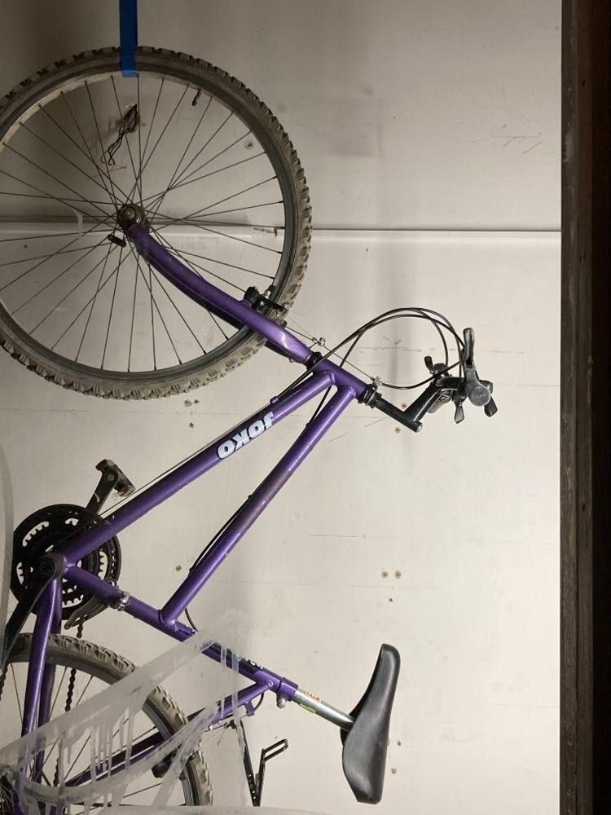

"The gallery will be transformed into a temporary pawn shop with real objects telling the stories of the original owners. In addition to a theoretical introduction about the typology of pawnshops, their social context and ethnographic display of "artefacts" with accompanying descriptions, there is a great deal of interaction with the public and the project's overlap into the socio-cultural scene," says Eva Truncová, the exhibition's curator.

The exhibition will be complemented on Sunday 23 April 2023 at 15:00 by a guided walk with the author Prokop Matěj through Brno's current and defunct bazaars and pawnshops. Their history, typology and the stylized aesthetics of the archive of collective memory, which is the result of the curators of each collection, will be briefly presented.

Architect Prokop Matěj (*1992) studied architecture and urban planning at the Czech Technical University in Prague and TU Delft. During and after his studies he completed several architectural internships in domestic and foreign studios, including JRKVC (SK), Schenker Salvi Weber (AT), and Consequence forma (CZ) in Brno.
The exhibition Pawnshops builds on his studio work at the Technical University of Delft (NL) and develops it in the format of an interactive installation in a showcase gallery in the centre of Brno.

Prokop Matěj - Pawnshops.
Gallery: Volume for engaged architecture
Window display in the passage from Šilingrova Square to the Big Spalíček
Dominikánská 342/6, 602 00 Brno
7.3.-13.5.2023 (nonstop)

Opening Tuesday 7 March at 18:00
Author.
Curator/producer: Eva Truncová
Graphic design: Pavel Holomek
Jan Kristek, Adéla Šoborová, Faculty of Architecture, Brno University of Technology, Poupě Brewery

